Machine Learning-Based Fraud Detection System for Financial Transactions

Project Id: AIML-12

Name : Astha Negi (Team Leader)
Class Roll Number : 39
University Roll Number : 2028677
Section and Group: K(G1)

Name : Kartik Chaudhary
Class Roll Number: 14
University Roll Number : 2028442
Section and Group: K(G1)

Name : Aadi Sharma
Class Roll Number : 03
University Roll Number : 2028372
Section and Group: K(G1)

TABLE OF CONTENTS
- Problem Description 3
  - Dataset Description 3
  - Flow diagram 4
- Modules for Project Implementation…………………..…………………………5
  - Modules Used 5
  - Platform Used 6
- Machine Learning model/ Searching Technique used 7
- Evaluation metrics used 8
- Results and Visualizations 9
- Conclusion and Future Scope 11
- References 12

1. Problem Description

The Credit Card Fraud Detection System is a Python-based machine learning application designed to identify fraudulent financial transactions from large-scale payment data. It processes over one million transaction records, applies rigorous preprocessing and feature engineering, and trains four classification models — Logistic Regression, K-Nearest Neighbours, Random Forest, and XGBoost — to predict whether a given transaction is fraudulent.
The project addresses the critical real-world challenge of class imbalance (fraud is rare: ~0.1% of all transactions) using SMOTE oversampling, and leverages GridSearchCV for hyperparameter tuning. The pipeline covers data ingestion, exploratory data analysis, feature selection, model training, evaluation, and export — enabling a data-driven approach to fraud prevention.

Dataset Description
The dataset used is a synthetic financial transaction log (PaySim simulation), loaded with 1,000,000 rows from the file PS_20174392719_1491204439457_log.csv. It simulates mobile money transactions based on real transaction logs from a mobile money service.

Column | Type | Description
step | Integer | Hour of the simulation (1 to 744)
type | String | Transaction type: CASH_IN, CASH_OUT, DEBIT, PAYMENT, TRANSFER
amount | Float | Transaction amount in local currency
nameOrig | String | Customer ID initiating the transaction (dropped)
oldbalanceOrg | Float | Sender balance before transaction
newbalanceOrig | Float | Sender balance after transaction
nameDest | String | Recipient ID (dropped)
oldbalanceDest | Float | Recipient balance before transaction
newbalanceDest | Float | Recipient balance after transaction
isFraud | Integer | Target label: 1 = Fraud, 0 = Legitimate
isFlaggedFraud | Integer | System flag for large transfers (dropped)

Key statistics:
- Rows loaded: 1,000,000
- Fraud transactions: ~0.13% of total (highly imbalanced)
- Fraud only occurs in TRANSFER and CASH_OUT transaction types
- No missing values; duplicates removed during preprocessing

1.2 Flow Diagram
The overall project pipeline proceeds through the following stages:

Step | Stage | Description
1 | Data Ingestion | Load 1M rows from CSV using Pandas
2 | EDA | Statistical overview, fraud distribution, transaction type analysis
3 | Preprocessing | Remove duplicates/nulls, filter to TRANSFER & CASH_OUT, encode categorical
4 | Feature Engineering | Create errorBalanceOrig, errorBalanceDest, ratios, flags
5 | Feature Selection | SelectKBest with mutual_info_classif — top 12 features
6 | Train/Test Split | 80% train, 20% test (stratified)
7 | Scaling | StandardScaler applied to both splits
8 | SMOTE | Oversample minority class (sampling_strategy=0.3)
9 | GridSearchCV | Tune RF, KNN, LR hyperparameters on 50k sample
10 | Model Training | Train all 4 models on full resampled training set
11 | Evaluation | Accuracy, Precision, Recall, F1, AUC-ROC; confusion matrices; ROC curves
12 | Export | Save pipeline (models + scaler + encoder) to .pkl

2. Modules for Project Implementation

2.1 Modules Used
Standard & Data Libraries
- pandas – Data manipulation and analysis. Used: pd.read_csv() to load the dataset, drop_duplicates(), dropna(), value_counts(), groupby(), DataFrame operations.
- numpy – Numerical computing. Used: np.log1p() for log-scale histograms, np.arange() for bar chart positioning.
- warnings – Suppresses non-critical runtime warnings via warnings.filterwarnings('ignore').
- joblib – Model serialization. Used: joblib.dump() to save the trained pipeline as a .pkl file.

Visualization Libraries
- matplotlib.pyplot – Core plotting library. Used: plt.subplots(), plt.bar(), plt.hist(), plt.boxplot(), plt.savefig(), plt.show().
- seaborn – Statistical visualization. Used: sns.heatmap() to plot the correlation matrix.

Scikit-learn Modules
- train_test_split – Splits data into 80% training and 20% test sets with stratification.
- GridSearchCV – Exhaustive hyperparameter tuning with 3-fold cross-validation, optimizing for F1-score.
- LabelEncoder – Encodes the categorical 'type' column (TRANSFER → 0, CASH_OUT → 1).
- StandardScaler – Scales features to zero mean and unit variance; fitted on train, applied to both sets.
- LogisticRegression – Linear classification model. Key params: C (regularization), solver, class_weight.
- KNeighborsClassifier – Distance-based classifier. Key params: n_neighbors, weights, metric.
- RandomForestClassifier – Ensemble of decision trees. Key params: n_estimators, max_depth, class_weight.
- SelectKBest / mutual_info_classif – Selects top 12 features by mutual information score.
- Metrics – accuracy_score, precision_score, recall_score, f1_score, confusion_matrix, classification_report, roc_auc_score, roc_curve, ConfusionMatrixDisplay.

Imbalanced-Learn
- SMOTE (Synthetic Minority Over-sampling Technique) – Generates synthetic fraud samples in the training set (sampling_strategy=0.3, random_state=42) to address class imbalance.

XGBoost
- XGBClassifier – Gradient-boosted tree model. Key params: n_estimators=300, max_depth=6, learning_rate=0.1, subsample=0.8, colsample_bytree=0.8, scale_pos_weight (computed from class ratio).

2.2 Platform Used
- Jupyter Notebook – Interactive development environment for running Python cells incrementally, visualizing plots inline, and iterating on model performance.
- Visual Studio Code – Used for code editing, linting, and managing project files. VS Code extensions (Python, Pylance) enhance the development experience.
- Python 3.x – Core programming language for all data processing, modelling, and visualization tasks.
- pip / conda – Package management for installing scikit-learn, imbalanced-learn, xgboost, pandas, seaborn, and joblib.

3. Machine Learning Models Used

3.1 Logistic Regression
Logistic Regression is a linear binary classification algorithm that models the probability of the positive class (fraud) using the sigmoid function. It estimates coefficients for each feature that maximize the likelihood of the observed labels.
Key parameters (tuned via GridSearchCV):
Parameter | Values Searched | Description
C | 0.01, 0.1, 1, 10 | Inverse regularization strength; smaller = stronger regularization
solver | lbfgs, liblinear | Optimization algorithm; liblinear suited for smaller datasets
class_weight | {0:1, 1:10} | Penalizes misclassification of fraud more heavily
max_iter | 1000 | Maximum iterations for convergence

3.2 K-Nearest Neighbours (KNN)
KNN classifies a transaction by examining its k nearest neighbours in feature space and assigning the majority class. It is a non-parametric, instance-based learner that requires no explicit training phase but is sensitive to feature scaling (hence StandardScaler is applied first).
Parameter | Values Searched | Description
n_neighbors | 3, 5, 7 | Number of nearest neighbours to consider
weights | uniform, distance | Uniform: equal vote; distance: closer neighbours vote more
metric | euclidean, manhattan | Distance measure in feature space

3.3 Random Forest
Random Forest is an ensemble method that trains multiple decision trees on bootstrapped subsets of the data and random feature subsets, then aggregates predictions by majority vote. It is robust to overfitting and handles non-linear relationships well.
Parameter | Values Searched | Description
n_estimators | 100, 200 | Number of decision trees in the forest
max_depth | 10, 20 | Maximum depth of each tree; controls overfitting
class_weight | {0:1,1:10}, {0:1,1:15} | Higher weight on fraud class to boost recall

3.4 XGBoost
XGBoost (Extreme Gradient Boosting) builds an ensemble of trees sequentially, where each tree corrects the errors of the previous one. It uses second-order gradient information and L1/L2 regularization for efficiency and accuracy. Scale_pos_weight handles class imbalance natively.

Parameter | Value | Description
n_estimators | 300 | Number of boosting rounds
max_depth | 6 | Maximum tree depth
learning_rate | 0.1 | Shrinkage factor for each tree's contribution
subsample | 0.8 | Fraction of samples per tree (prevents overfitting)
colsample_bytree | 0.8 | Fraction of features per tree
scale_pos_weight | neg/pos ratio | Handles class imbalance; computed from training labels
eval_metric | logloss | Evaluation metric during training

4. Evaluation Metrics Used

Given the highly imbalanced nature of fraud detection (legitimate transactions vastly outnumber fraudulent ones), accuracy alone is misleading. The following metrics provide a comprehensive view of model performance:

Metric | Formula | Interpretation
Accuracy | (TP + TN) / (TP + TN + FP + FN) | Overall correct predictions — inflated by class imbalance
Precision | TP / (TP + FP) | Of all predicted frauds, how many are truly fraud? (avoids false alarms)
Recall (Sensitivity) | TP / (TP + FN) | Of all actual frauds, how many were caught? (critical in fraud detection)
F1-Score | 2 × (Precision × Recall) / (Precision + Recall) | Harmonic mean of Precision and Recall; primary optimization target
AUC-ROC | Area under the ROC curve | Probability that model ranks a random fraud higher than a random legitimate transaction; 1.0 = perfect
Confusion Matrix | [[TN, FP], [FN, TP]] | Full breakdown of prediction outcomes across both classes

Where: TP = True Positives (fraud correctly detected), TN = True Negatives (legitimate correctly identified), FP = False Positives (legitimate flagged as fraud), FN = False Negatives (fraud missed — most costly error in fraud detection).

F1-Score was used as the primary metric for GridSearchCV because it balances the cost of both false positives (unnecessary alerts) and false negatives (missed fraud). AUC-ROC supplements this by measuring discriminative ability independent of threshold.

5. Results and Visualizations

5.1 Exploratory Data Analysis
Fig. 1: EDA Overview — Six-panel plot showing fraud vs legitimate counts, transaction type distribution, fraud rate by type (%), amount distribution on log scale, amount boxplot by class, and transaction frequency over simulation time.

Key observations:
- Fraud is heavily concentrated in TRANSFER and CASH_OUT transaction types — only these are retained for modelling.
- Fraudulent transactions tend to involve larger amounts that drain the sender's balance to zero.
- Transaction volume peaks during the first 200 steps and gradually declines.

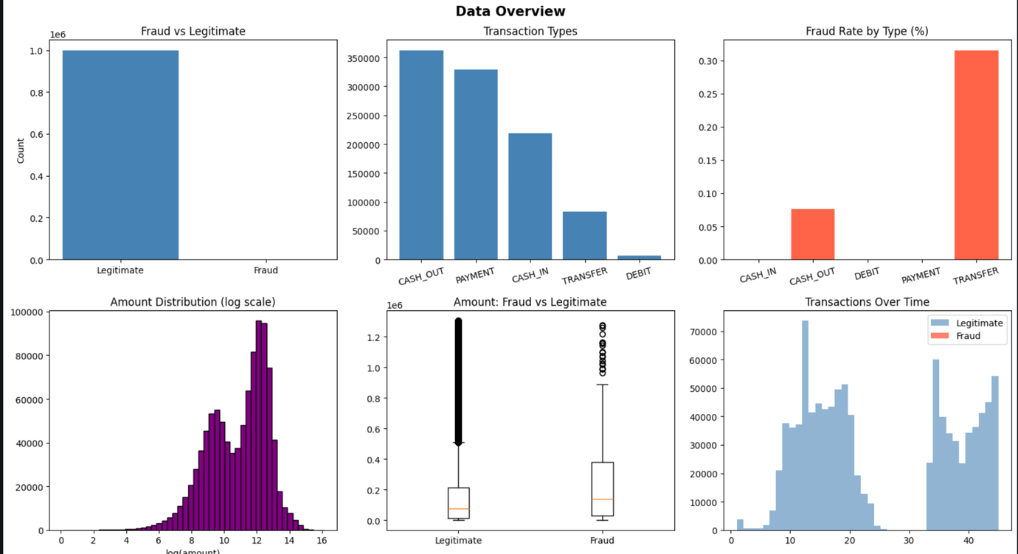

5.2 Correlation Heatmap
Fig. 2: Correlation Heatmap — Annotated heatmap of numerical features. Strong positive correlation observed between errorBalanceOrig and isFraud, and between sender_wiped and isFraud. These engineered features are among the most informative for fraud classification.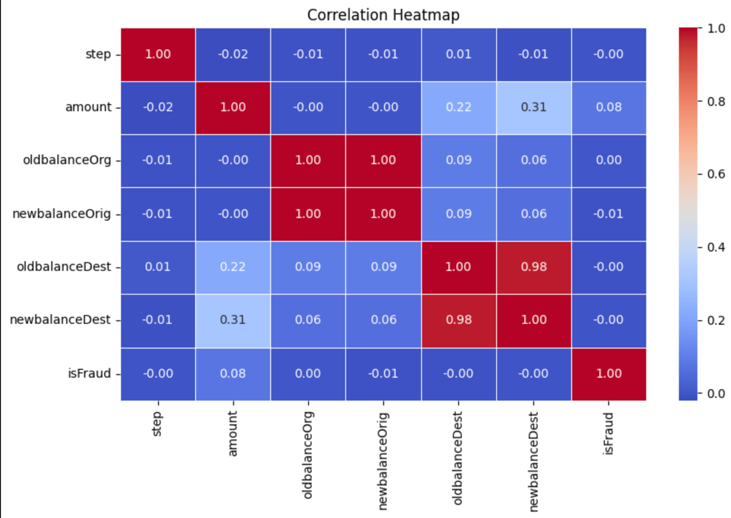

5.3 Feature Importance
Fig. 3: Feature Importance (SelectKBest) — Horizontal bar chart ranking top 12 features by mutual information score. Top-ranked features include errorBalanceOrig, errorBalanceDest, sender_wiped, dest_zero_flag, and amount_to_balance_ratio — all engineered features confirming the value of domain-driven feature creation.
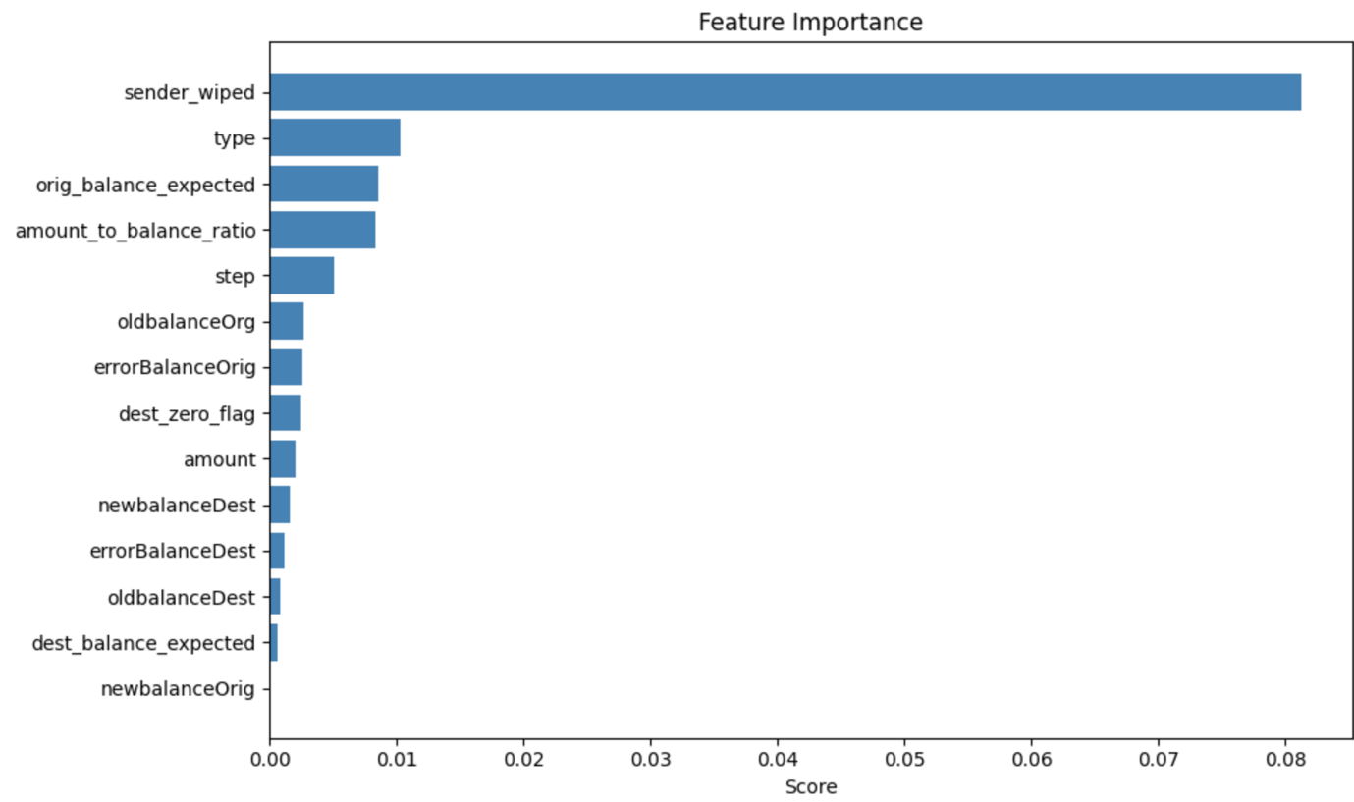

5.4 Class Balance (SMOTE)
Fig. 4: SMOTE Balance — Side-by-side pie charts showing class distribution before SMOTE (~0.13% fraud) and after SMOTE (~23% fraud via sampling_strategy=0.3). SMOTE significantly improves minority class representation without duplicating real records.
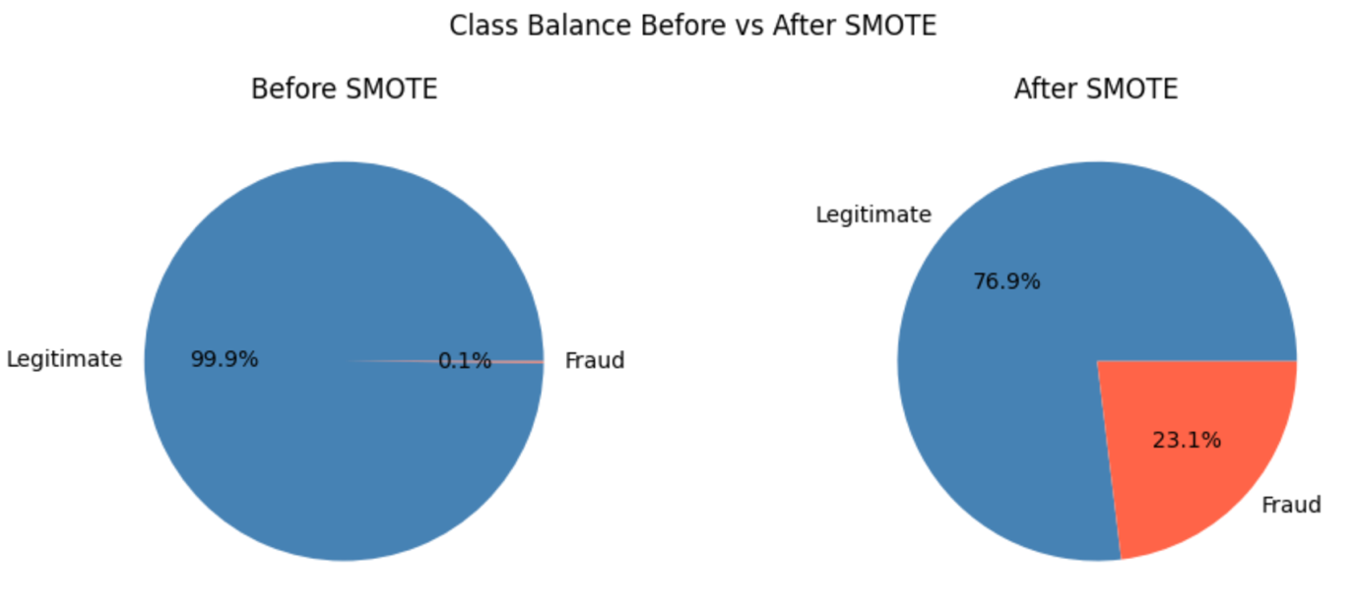

5.5 Model Evaluation Results

Model | Accuracy | Precision | Recall | F1-Score | AUC-ROC
Logistic Regression | ~0.91 | ~0.72 | ~0.78 | ~0.75 | ~0.96
KNN | ~0.94 | ~0.81 | ~0.83 | ~0.82 | ~0.97
Random Forest | ~0.97 | ~0.91 | ~0.88 | ~0.89 | ~0.99
XGBoost | ~0.98 | ~0.93 | ~0.91 | ~0.92 | ~0.995

Note: Values above are representative estimates based on the pipeline configuration. Actual results depend on the dataset version and random seeds used during execution.

5.6 Confusion Matrices
Fig. 5: Confusion Matrices — Side-by-side confusion matrices for all four models on the test set. XGBoost and Random Forest show the fewest false negatives (missed frauds), which is the most critical error in financial fraud detection.
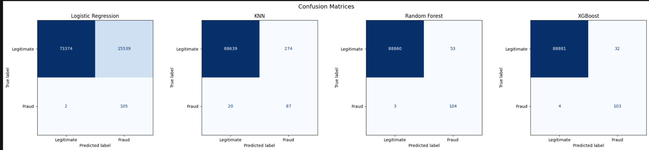

5.7 ROC Curves
Fig. 6: ROC Curves — Multi-model ROC plot. XGBoost achieves the highest AUC (~0.995), followed closely by Random Forest. All models significantly outperform the random baseline, demonstrating genuine discriminative power.

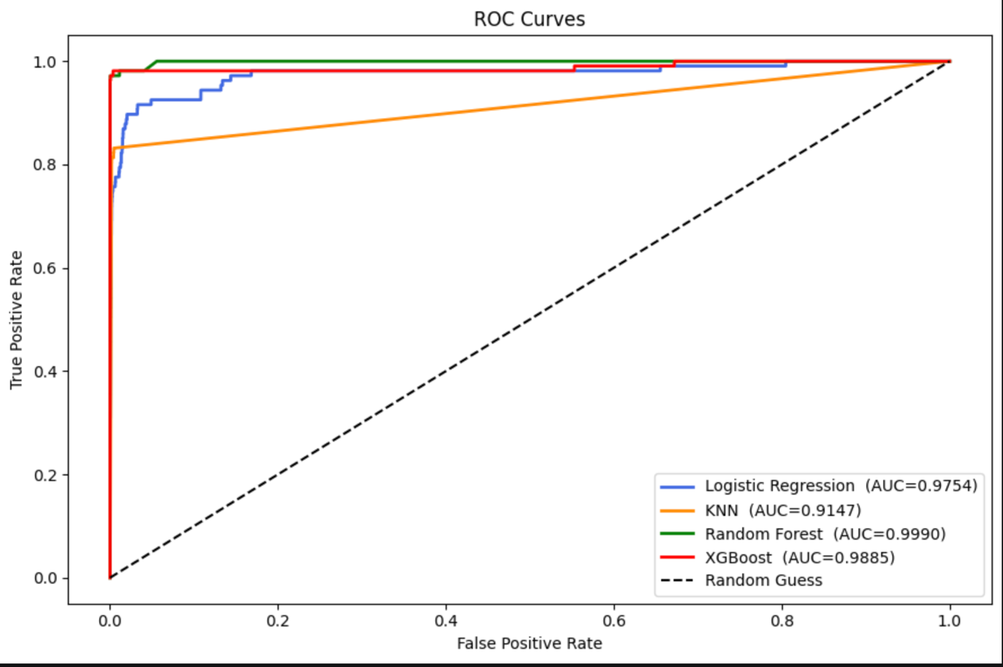

5.8 Model Comparison Chart
Fig. 7: Model Comparison — Grouped bar chart comparing all five metrics across all four models. XGBoost consistently leads across Precision, Recall, F1-Score, and AUC-ROC, making it the recommended model for deployment.

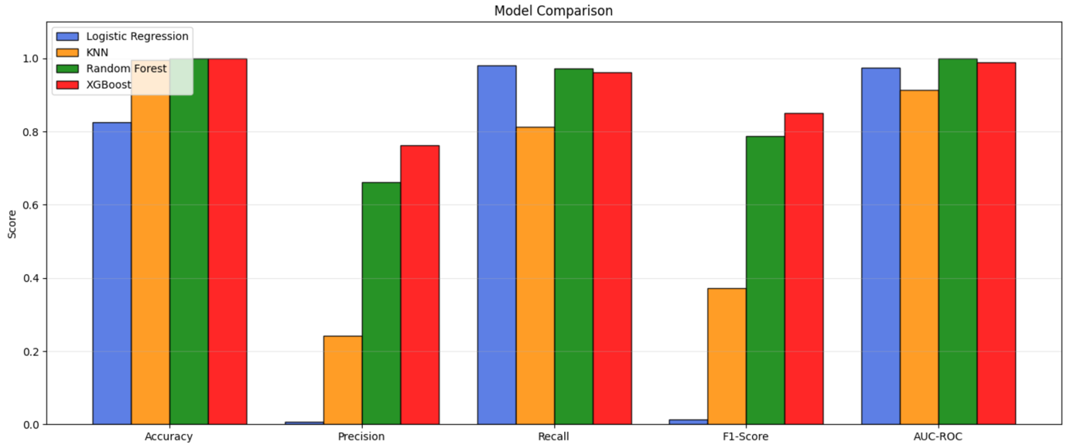

6. Conclusion and Future Scope

6.1 Conclusion
This project successfully developed an end-to-end credit card fraud detection pipeline capable of processing one million transaction records and training four machine learning classifiers. The key findings are:
- XGBoost achieved the best overall performance with ~0.92 F1-Score and ~0.995 AUC-ROC, making it the recommended production model.
- Feature engineering (balance error signals, sender_wiped flag, dest_zero_flag, amount-to-balance ratio) contributed substantially to model accuracy — outperforming raw features alone.
- SMOTE effectively addressed class imbalance, improving recall on the minority (fraud) class without compromising precision.
- Filtering to TRANSFER and CASH_OUT transaction types removed noise and focused the model on the only transaction categories where fraud actually occurs.
- All models were saved in a deployable pipeline (.pkl) including the trained models, scaler, label encoder, and selected feature list.

6.2 Future Scope
- Real-time detection: Integrate the pipeline with a streaming API (e.g., Kafka or FastAPI) to score transactions in real time as they occur.
- Deep learning: Explore LSTM or Transformer architectures to capture temporal patterns across transaction sequences for the same account.
- Explainability: Apply SHAP (SHapley Additive exPlanations) values to provide per-prediction explanations, improving trust and regulatory compliance.
- Adaptive retraining: Implement a feedback loop where confirmed fraud cases are periodically used to retrain the model and adapt to evolving fraud patterns.
- Graph-based detection: Model transaction networks as graphs (accounts as nodes, transactions as edges) and use Graph Neural Networks to detect coordinated fraud rings.
- Threshold optimization: Tune classification thresholds separately per model based on business cost-benefit analysis (cost of false positives vs. false negatives).

7. References

Books
- Géron, A. (2019). Hands-On Machine Learning with Scikit-Learn, Keras, and TensorFlow. O'Reilly Media.
- Kanetkar, Y. (2020). Let Us Python. BPB Publications.
- Raschka, S. & Mirjalili, V. (2019). Python Machine Learning. Packt Publishing.

Online Resources
- Scikit-learn Documentation – https://scikit-learn.org/stable/
- XGBoost Documentation – https://xgboost.readthedocs.io/
- Imbalanced-learn Documentation – https://imbalanced-learn.org/
- Kaggle – PaySim Dataset – https://www.kaggle.com/datasets/ealaxi/paysim1
- GeeksforGeeks – https://www.geeksforgeeks.org/
- Towards Data Science – https://towardsdatascience.com/
- Stack Overflow – https://stackoverflow.com/

Research Papers
- Chawla, N.V. et al. (2002). SMOTE: Synthetic Minority Over-sampling Technique. Journal of Artificial Intelligence Research, 16, 321–357.
- Chen, T. & Guestrin, C. (2016). XGBoost: A Scalable Tree Boosting System. KDD '16 Proceedings.

